Demonstration of Image Recognition Service in Azure cloud service

Project Done by

**PRANAV S**

Procedure for Image recognition using Azure Cloud Services

Step 1 :

Create a Microsoft Azure Portal by signing in using mail ID

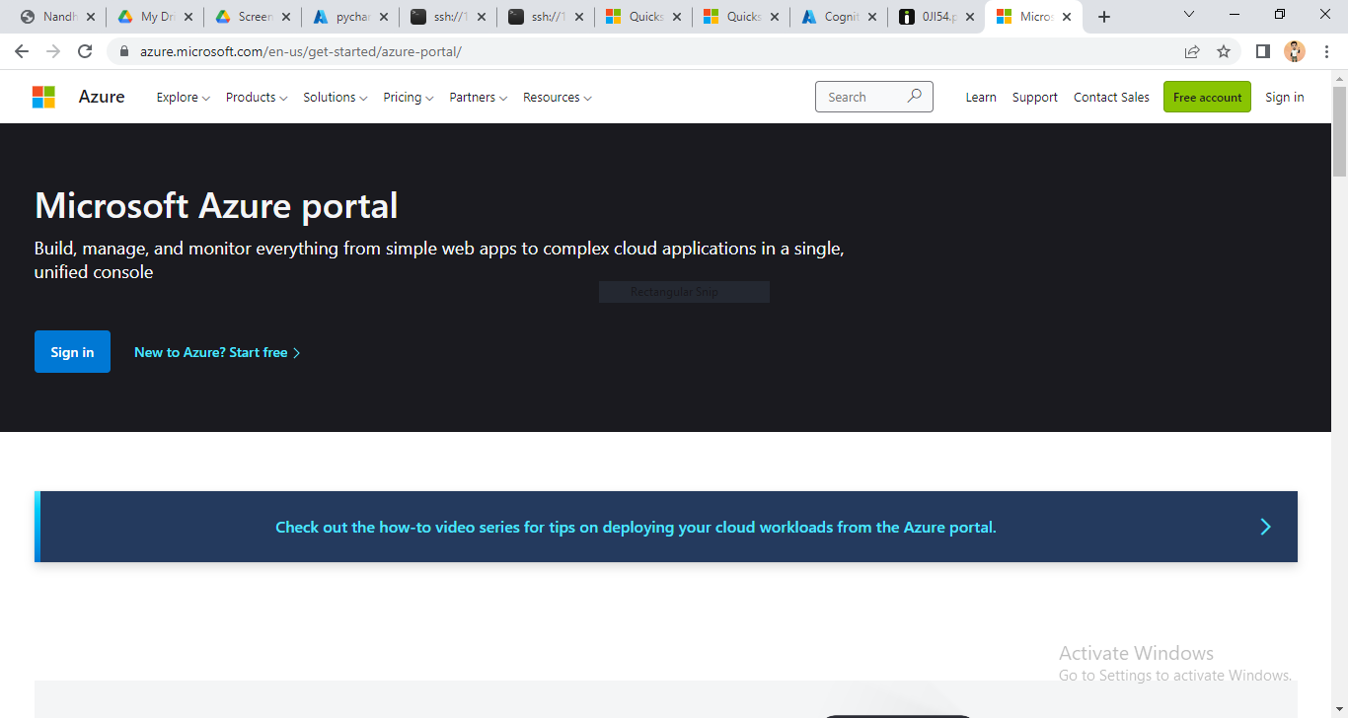

Step 2:

Now you can access azure portal

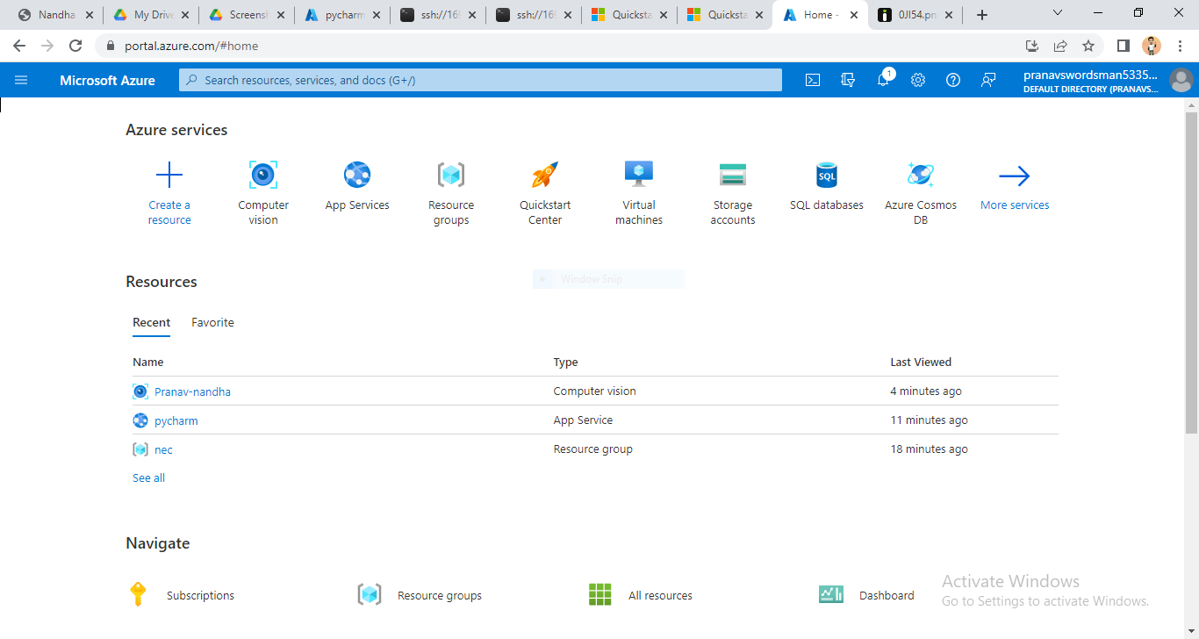

Step 3:

Select Computer Vision Service provided by Azure for Image or text recognition

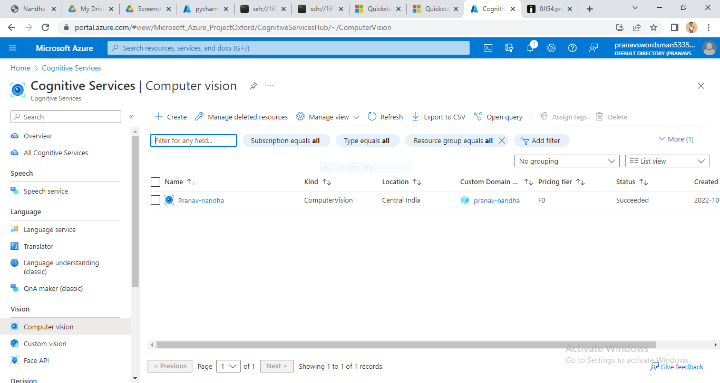

Step 3:

Create an instance for the service

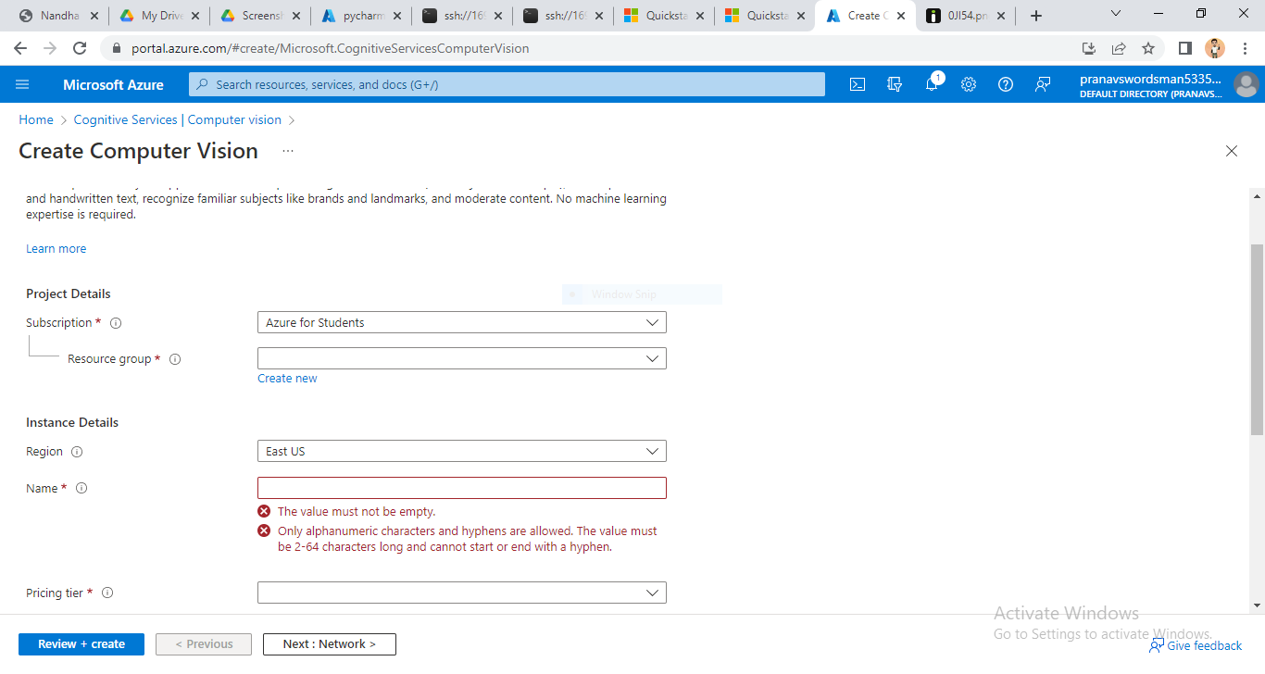

Step 4:

You can access and get the subscription keys for the service

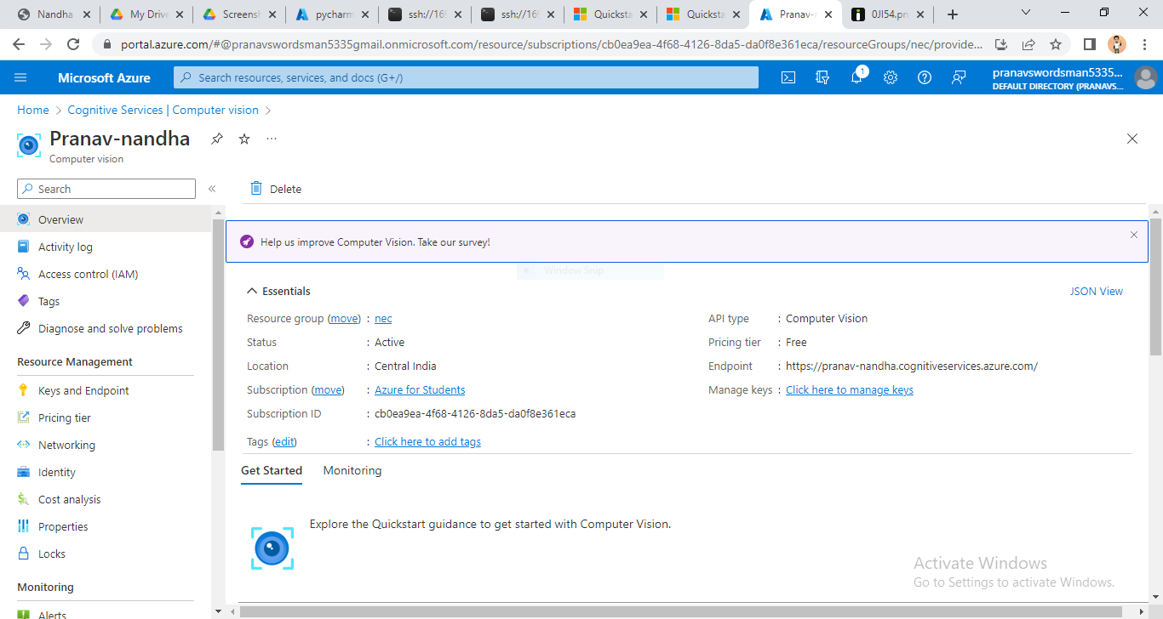

Step 5:

As our project is done using python code we need to create a python web app in Azure Portal

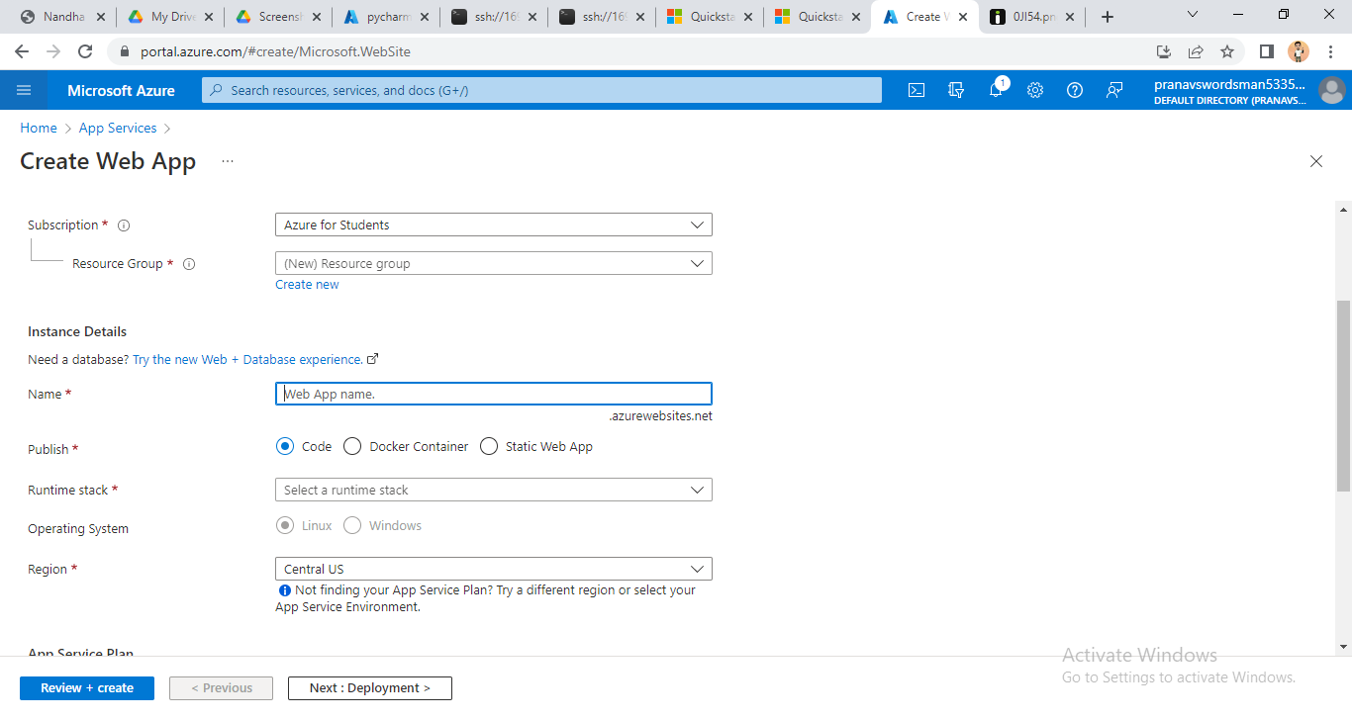

Step 6:

Now you can access to python web app in Azure portal

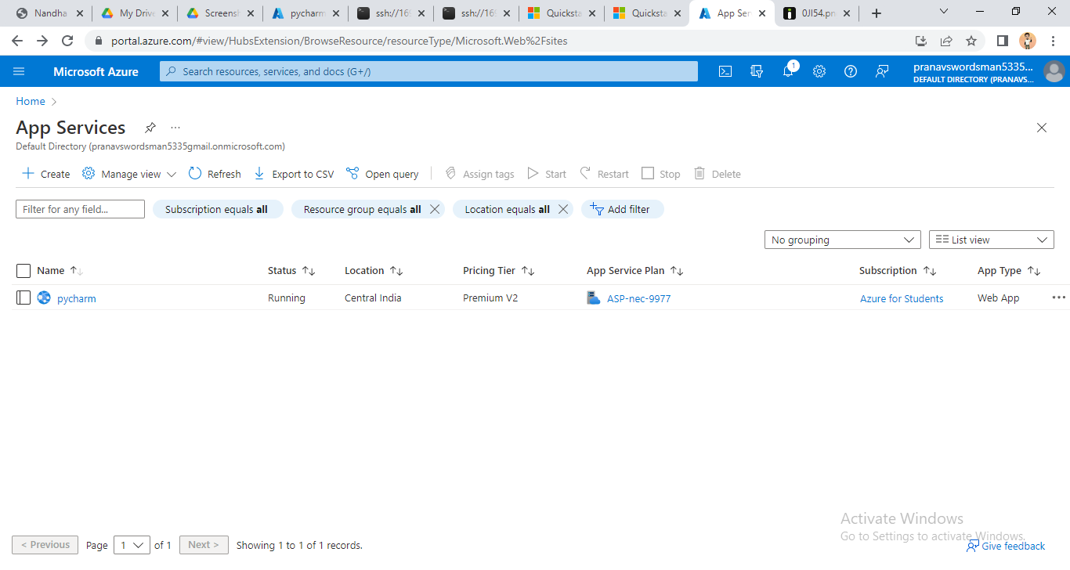

Step 7:

By opening SSH console we can write our python code for image recognition

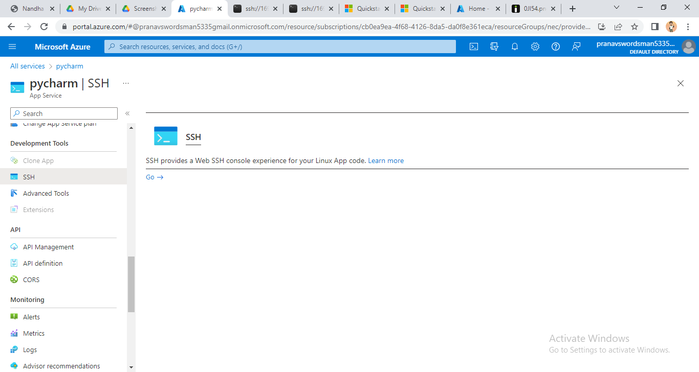

Step 8:

Now the console gets open

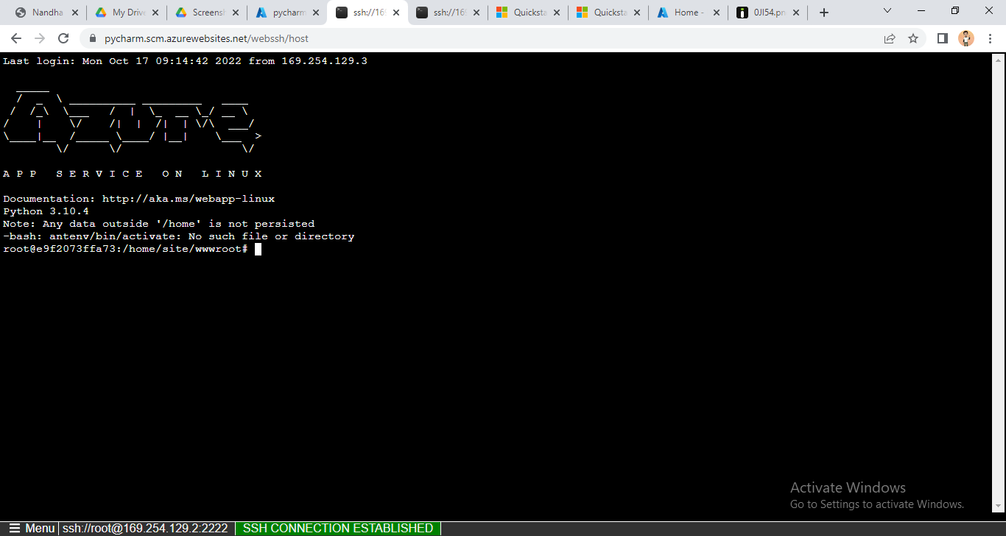

Step 9:

Now we can type our code using the Linux SSH console

The code is given below:

No 1: Install the client library.

You can install the client library with:

**pip install --upgrade azure-cognitiveservices-vision-computervision**

No 2: Also install the Pillow library.

**pip install pillow**

No 3: Create a new Python application

**file_name.py**

No 4: Find the key and endpoint.

Go to the Azure portal. If the Computer Vision resource you created in the **Prerequisites** section deployed successfully, click the **Go to Resource** button under **Next Steps**. You can find your key and endpoint in the resource's **key and endpoint** page, under **resource management**.

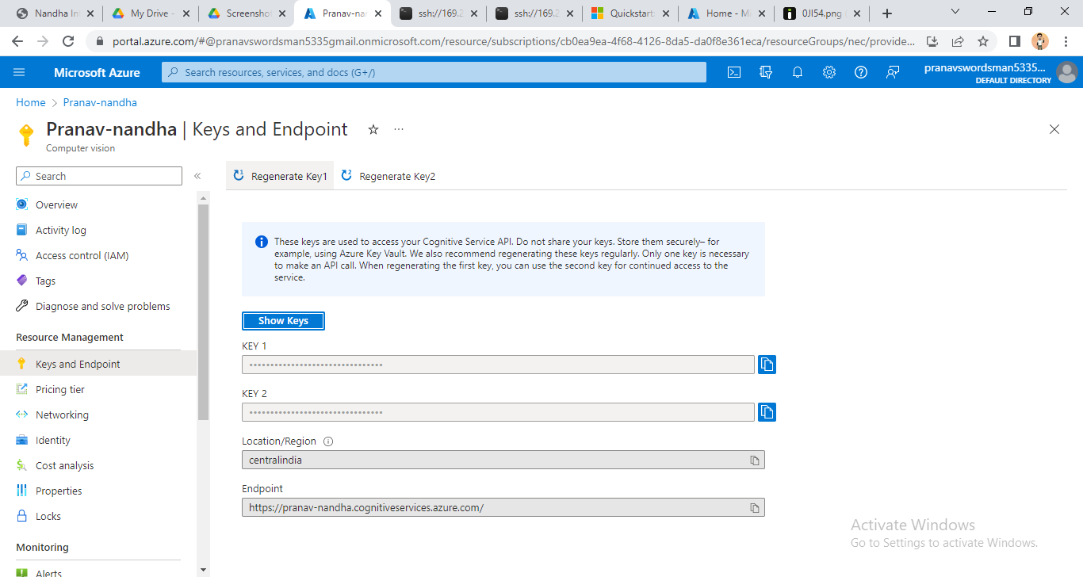

No 5: Replace the contents of file_name.py with the following code.

**from azure.cognitiveservices.vision.computervision**

**import ComputerVisionClient**

**from azure.cognitiveservices.vision.computervision.models**

**import OperationStatusCodes**

**from azure.cognitiveservices.vision.computervision.models**

**import VisualFeatureTypes**

**from msrest.authentication import CognitiveServicesCredentials**

**from array import array**

**import os**

**from PIL import Image**

**import sys**

**import time**

**subscription_key = "720436171a4a46c1a228c59cc04c766e"**

**endpoint = "https://pranav-nandha.cognitiveservices.azure.com/"**

**computervision_client = ComputerVisionClient(endpoint, CognitiveServicesCredentials(subscription_key))**

**print("===== Read File - remote =====")**

**read_image_url = "https://i.stack.imgur.com/0Jl54.png"**

**read_response = computervision_client.read(read_image_url, raw=True)**

**read_operation_location = read_response.headers["Operation-Location"]**

**operation_id = read_operation_location.split("/")[-1]**

**while True:**

**read_result = computervision_client.get_read_result(operation_id)**

**if read_result.status not in ['notStarted', 'running']:**

**break**

**time.sleep(1)**

**# Print the detected text, line by line**

**if read_result.status == OperationStatusCodes.succeeded:**

**for text_result in read_result.analyze_result.read_results:**

**for line in text_result.lines:**

**print(line.text)**

**print(line.bounding_box)**

**print()**

**print("End of Text Recognition..")**

No 6: By adding subscription key, endpoint, and Image Url we can run and recognize any image and can get output

**OUTPUT**

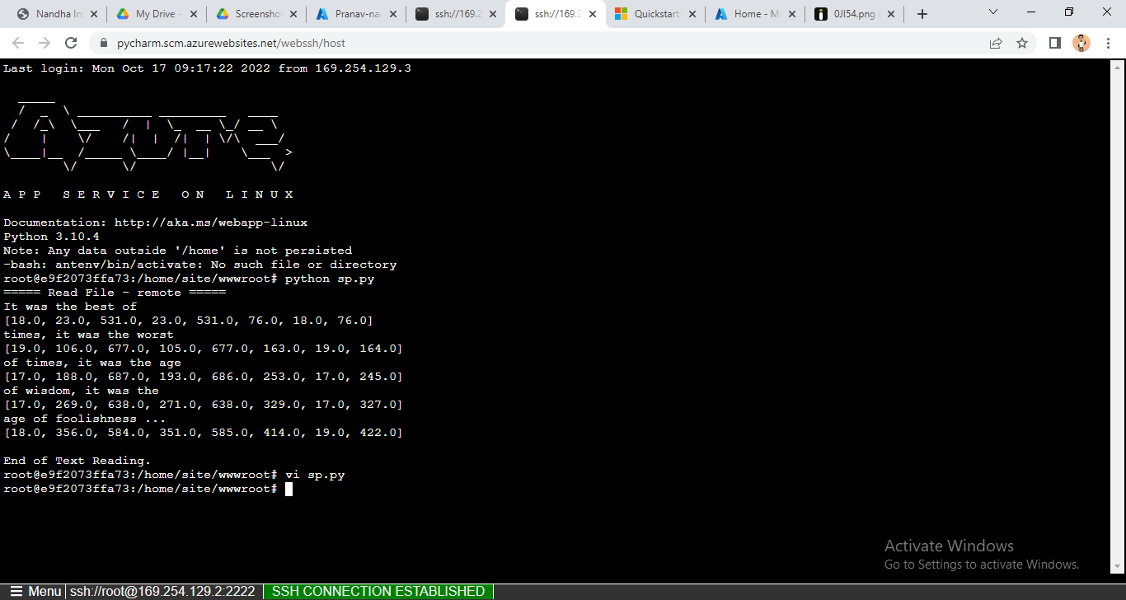

THANK YOU...